Perioperative Care

Pre-operative screening: All patients visited the pre-operative outpatient clinic. After admittance, all patients were assessed by an anesthesiologist and a thoracic surgeon on the day before surgery. In case of suspicion of an active infection e.g. on the basis of respiratory symptoms or elevated temperature, surgery was postponed.
Anaesthesia: Standard premedication and induction medication were followed by total intravenous anaesthesia. All patients received a central venous and an arterial catheter, standard surgical antibiotic prophylaxis, and tranexamic acid (loading dose 15 mg/kg anticipating a perfusor 5 mg/kg/hr) to minimise perioperative blood loss. Mechanical ventilation consisted of a standard protocol with low pressure and low tidal volume during CPB to prevent atelectasis of the lung. Inotropic and vasoactive agents were administered on indication. Applied transfusion triggers were congruent with the national guidelines[1] and corticosteroids were only administered in pre-defined situations, e.g. chronic corticosteroid-use, severe inflammatory response with hemodynamic instability during surgery.
Cardiopulmonary Bypass: A heart-lung machine (S3; Sorin Group) with a centrifugal blood pump (Revolution; Sorin Group) and a hollow fibre membrane oxygenator (Maquet Quadrox-I or Terumo FX15) was used. The circuit was primed with hydroxyethyl starch 130 (Voluven 6%; Fresenius Kabi Norge AS), Mannitol 15%, Ringer’s solution and Heparin. Tubing was coated with bio-inert heparin-free polymers (SAFELINE; MAQUET Holding BV & Co KG). Intermittent warm antegrade blood cardioplegia was applied. Anticoagulant therapy consisted of heparin (target Activated clotting time > 400s) which was antagonised with protamine sulphate at the end of the procedure. The patient’s core temperature was maintained at 34ºC to 36ºC, except for aortic surgery where active cooling (up to 20ºC) was used to prevent brain ischemia.
Postoperative care: Patients were treated according to a so called “fast-track” protocol[2] In short: when hemodynamically stable and with a core temperature of > 36 °C, patients were extubated when the following criteria were met: 1) Ramsay score 2-3,[3] 2) Arterial pO2 > 9 kPa and FiO2 40%, 3) pH > 7.30 and 4) decreasing thoracic drain production < 50-100ml/hour. Patients were discharged from the ICU on the first postoperative day, unless the patient’s hemodynamic and respiratory status required prolonged ICU stay. Hemodynamic monitoring was performed by an arterial and central venous catheter and, on indication, with a pulmonary artery catheter. In patients with low cardiac output, dobutamin, enoximone/milrinone, and noradrenaline were administered as inotropic and vasoactive agents.

Formulas and definitions
P/F ratio = PaO2 / FiO2
The ratio of arterial oxygen partial pressure (PaO2 in mmHg) to fractional inspired oxygen (FiO2) .
A-a gradient = (F_{i}O₂ (P_{atm} - P_{H2O}) - P_{a}CO2) - P_{a}O₂
0,8

ARDS criteria according to “the Berlin Definition” [4]
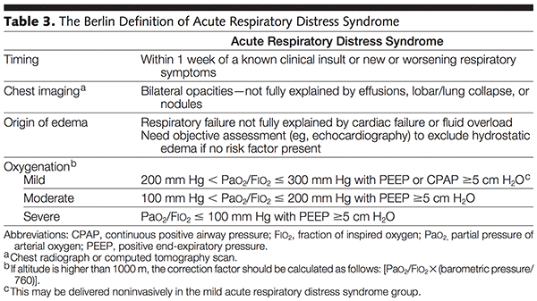

References
1. Richtlijn Bloedtransfusie beleid Nederlands: Federation of Medical Speciaslist, the Netherlands. Available from: https://richtlijnendatabase.nl/richtlijn/bloedtransfusiebeleid/startpagina_-_bloedtransfusiebeleid.html.
2. Silbert BS, Santamaria JD, O'Brien JL, Blyth CM, Kelly WJ, Molnar RR. Early extubation following coronary artery bypass surgery: a prospective randomized controlled trial. The Fast Track Cardiac Care Team. Chest. 1998;113(6):1481-8. Epub 1998/06/19. doi: 10.1378/chest.113.6.1481. PubMed PMID: 9631781.
3. Ramsay MA, Savege TM, Simpson BR, Goodwin R. Controlled sedation with alphaxalone-alphadolone. Br Med J. 1974;2(5920):656-9. Epub 1974/06/22. doi: 10.1136/bmj.2.5920.656. PubMed PMID: 4835444; PubMed Central PMCID: PMCPMC1613102.
4. Ranieri VM, Rubenfeld GD, Thompson BT, Ferguson ND, Caldwell E, Fan E, et al. Acute respiratory distress syndrome: the Berlin Definition. Jama. 2012;307(23):2526-33. doi: 10.1001/jama.2012.5669. PubMed PMID: 22797452.

