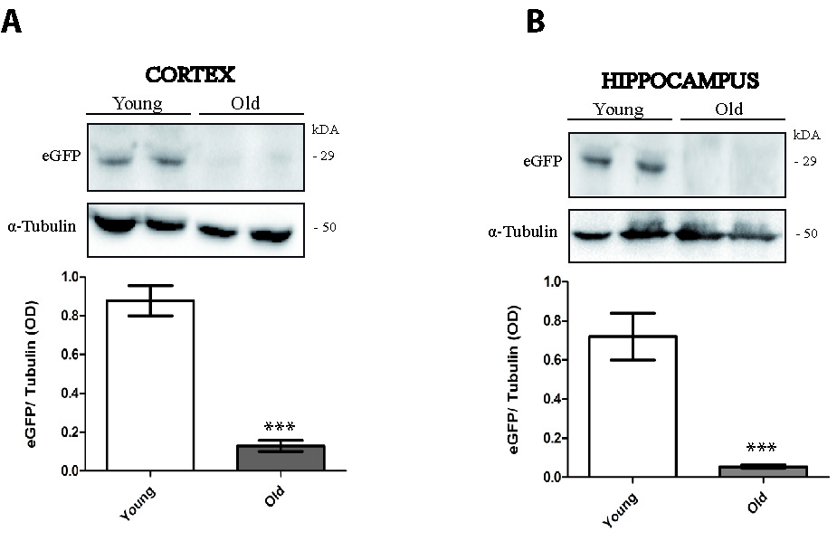
Supplementary Figure 1: AAV9-mediated eGFP expression was greatly reduced in cortex and hippocampus in old mice respect to young mice.
A. eGFP levels were analized by western blot in cortex. n = 4 animals per group; ***p<0.0001 old vs. young mice (t -test two tailed).
B. eGFP levels by Western blot in hippocampus. n = 4 animals per group; ***p<0.0001 old vs. young mice (t -test two tailed).

