Design, Synthesis, In silico Docking Prediction of Novel Triazolyl Tetrazole Derivatives: Evaluation of Anticancer and SIRT1 inhibition Activity

Supporting Information (SI)
Spectroscopic data
(S)-9-(4-(((1-(4-hydroxyphenyl)-1H-tetrazol-5-yl)thio)methyl)-1H-1,2,3-triazol-1-yl)-6,7,8,9-tetrahydro-5H-cyclohepta[b]pyridin-5-one (8b)
¹H NMR (400 MHz, CDCl₃, δ, ppm): 9.64 (brs, 1H, OH), 7.82 (d, 1H, J = 8.9 Hz, Ar-H), 7.70 (t, 1H, J = 9.3 Hz, Ar-H), 7.37 (d, 1H, J = 8.9 Hz, Ar-H), 7.29 (s, 1H, triazole H), 7.09 (d, 2H, J = 8.8 Hz, Ar-H), 6.83 (d, 2H, J = 8.8 Hz, Ar-H), 4.60 (s, 2H, CH₂), 4.37 (m, 1H, CH), 3.09 (m, 1H, CH), 2.83 (m, 1H, CH), 2.55 (t, 1H, J = 9.9 Hz, CH), 2.12 (m, 1H, CH), 1.76 (t, 2H, J = 10.2 Hz, CH). ¹³C NMR (100 MHz, CDCl₃, δ, ppm): 193.51, 169.60, 158.55, 153.94, 146.12, 136.32, 132.66, 131.56, 130.68, 130.64, 128.17, 127.25, 126.99, 125.47, 124.51, 68.47, 41.65, 37.36, 34.12, 24.55. IR (KBr, cm⁻¹) υ: 3392.95 (‒OH), 2977.88, 2928.32 (‒CH), 1736.33 (C=O), 1592.25 (C=C), 1438.18 (C=N), 1208.51 (CSC). HRMS (m/z): 435.2419 [M + H]⁺. Elemental analysis for C₂₀H₁₈N₈O₂S: calcd, C, 55.13; H, 4.03; N, 25.55; S, 7.16; found, C, 55.34; H, 4.23; N, 25.88; S, 7.29.
(S)-9-(4-(((1-(4-methoxyphenyl)-1H-tetrazol-5-yl)thio)methyl)-1H-1,2,3-triazol-1-yl)-6,7,8,9-tetrahydro-5H-cyclohepta[b]pyridin-5-one (8c)
¹H NMR (400 MHz, CDCl₃, δ, ppm): 8.10 (d, 1H, J = 8.9 Hz, Ar-H), 7.91 (t, 1H, J = 9.3 Hz, Ar-H), 7.31 (d, 1H, J = 8.9 Hz, Ar-H), 7.22 (s, 1H, triazole H), 7.12 (d, 2H, J = 8.8 Hz, Ar-H), 6.87 (d, 2H, J = 8.8 Hz, Ar-H), 5.14 (s, 2H, CH₂), 4.77 (t, 1H, J = 9.9 Hz, CH), 3.73 (s, 3H, OCH₃), 3.12 (m, 1H, CH), 2.67 (m, 1H, CH), 2.38 (m, 1H, CH), 2.13 (t, 1H, J = 9.9 Hz, CH), 1.70 (m, 1H, CH). ¹³C NMR (100 MHz, CDCl₃, δ, ppm): 191.14, 167.08, 160.56, 156.15, 150.28, 145.99, 136.52, 132.26, 130.60, 129.75, 128.60, 127.29, 127.21, 127.07, 126.57, 124.43, 67.08, 58.41, 39.77, 32.58, 29.66, 24.72. IR (KBr, cm⁻¹) υ: 3137.08 (=CH), 2964.89, 2841.93 (‒CH), 1735.30 (C=O), 1575.24, 1509.93 (C=C), 1466.50 (C=N), 1391.39 (N=N), 1268.61 (CSC), 1163.23 (COC). HRMS (m/z): 449.2276 [M + H]⁺. Elemental analysis for C₂₁H₂₀N₈O₂S: calcd, C, 56.02; H, 4.04; N, 24.55; S, 7.33; found, C, 56.24; H, 4.49; N, 24.98; S, 7.14.
(S)-9-(4-(((1-(p-tolyl)-1H-tetrazol-5-yl)thio)methyl)-1H-1,2,3-triazol-1-yl)-6,7,8,9-tetrahydro-5H-cyclohepta[b]pyridin-5-one (8d)
¹H NMR (400 MHz, CDCl₃, δ, ppm): 8.47 (d, 1H, J = 8.9 Hz, Ar-H), 7.87 (t, 1H, J = 9.3 Hz, Ar-H), 7.75 (s, 1H, triazole H), 7.70 (d, 1H, J = 8.9 Hz, Ar-H), 7.60 (d, 2H, J = 8.8 Hz, Ar-H), 7.37 (d, 2H, J = 8.8 Hz, Ar-H), 5.12 (s, 2H, CH₂), 4.82 (t, 1H, J = 9.9 Hz, CH), 2.71 (s, 3H, CH₃), 2.51 (t, 1H, J = 9.9 Hz, CH), 2.19 (m, 1H, CH), 1.76 (m, 1H, CH), 1.70 (m, 1H, CH), 1.45 (t, 2H, J = 9.8 Hz, CH). ¹³C NMR (100 MHz, CDCl₃, δ, ppm): 191.24, 168.31, 155.48, 145.80, 140.59, 136.23, 130.58, 130.21, 129.18, 127.32, 127.02, 124.73, 124.45, 122.37, 68.31, 41.67, 34.92, 32.59, 26.12, 24.70. IR (KBr, cm⁻¹) υ: 3197.10 (=CH), 2966.39, 2879.33 (‒CH), 1755.15 (C=O), 1590.91, 1505.18 (C=C), 1449.50 (C=N), 1376.72 (N=N), 1269.35 (CSC). HRMS (m/z): 433.2254 [M + H]⁺. Elemental analysis for C₂₁H₂₀N₈OS: calcd, C, 58.32; H, 4.66; N, 25.91; S, 7.41; found C, 58.55; H, 4.98; N, 26.05; S, 7.22.
(S)-9-(4-(((1-(4-chlorophenyl)-1H-tetrazol-5-yl)thio)methyl)-1H-1,2,3-triazol-1-yl)-6,7,8,9-tetrahydro-5H-cyclohepta[b]pyridin-5-one (8e)
¹H NMR (400 MHz, CDCl₃, δ, ppm): 8.49 (d, 1H, J = 8.9 Hz, Ar-H), 8.01 (s, 1H, triazole H), 7.86 (d, 2H, J = 8.8 Hz, Ar-H), 7.71 (d, 1H, J = 8.9 Hz, Ar-H), 7.59 (t, 1H, J = 9.8 Hz, Ar-H), 7.20 (d, 2H, J = 8.8 Hz, Ar-H), 5.06 (s, 2H, CH₂), 4.75 (t, 1H, J = 9.9 Hz, CH), 3.51 (m, 1H, CH), 3.23 (t, 1H, J = 9.9 Hz, CH), 2.57 (m, 1H, CH), 2.02 (t, 1H, J = 9.9 Hz, CH), 1.60 (m, 2H, CH). ¹³C NMR (100 MHz, CDCl₃, δ, ppm): 192.68, 167.13, 152.26, 145.62, 137.39, 133.27, 132.03, 132.19, 131.80, 129.33, 128.77, 128.11, 127.07, 126.03. IR (KBr, cm⁻¹) υ: 3181.26 (=CH), 2961.34, 2896.62 (‒CH), 1762.08 (C=O), 1586.94, 1505.17 (C=C), 1474.16 (C=N), 1363.92 (N=N), 1269.05 (CSC), 866.44 (CCl). HRMS (m/z): 453.1910 [M + H]⁺. Elemental analysis for C₂₀H₁₇ClN₈OS: calcd, C, 53.04; H, 3.78; Cl, 7.83; N, 24.74; S, 7.08; found C, 52.78; H, 3.33; Cl, 7.46; N, 24.30; S, 6.88.
(S)-9-(4-(((1-(2,4-dichlorophenyl)-1H-tetrazol-5-yl)thio)methyl)-1H-1,2,3-triazol-1-yl)-6,7,8,9-tetrahydro-5H-cyclohepta[b]pyridin-5-one (8f)
¹H NMR (400 MHz, CDCl₃, δ, ppm): 8.23 (d, 1H, J = 8.9 Hz, Ar-H), 7.86 (d, 1H, J = 8.9 Hz, Ar-H), 7.72 (s, 1H, triazole H), 7.57 (t, 2H, J = 9.8 Hz, Ar-H), 7.35 (s, 1H, Ar-H), 6.90 (d, 1H, J = 8.9 Hz, Ar-H), 5.09 (s, 2H, CH₂), 4.70 (t, 1H, J = 9.9 Hz, CH), 3.10 (m, 1H, CH), 2.81 (t, 1H, J = 9.9 Hz, CH), 2.18 (m, 1H, CH), 1.90 (m, 1H, CH), 1.52 (t, 1H, J = 9.9 Hz, CH), 1.25 (t, 1H, J = 9.9 Hz, CH). ¹³C NMR (100 MHz, CDCl₃, δ, ppm): 191.40, 167.29, 157.22, 148.70, 145.08, 136.55, 133.64, 131.67, 130.27, 130.12, 129.07, 129.46, 128.78, 127.55, 125.08, 124.80, 67.50, 40.82, 36.12, 32.67, 24.65. IR (KBr, cm⁻¹) υ: 3185.75 (=CH), 2970.78, 2875.99 (‒CH), 1744.40 (C=O), 1576.02, 1501.66 (C=C), 1465.45 (C=N), 1368.42 (N=N), 1266.15 (CSC), 884.56 (CCl). HRMS (m/z): 488.1435 [M + H]⁺. Elemental analysis for C₂₀H₁₆Cl₂N₈OS: calcd, C, 49.03; H, 3.21; Cl, 14.10; N, 22.37; S, 6.03; found C, 49.29; H, 3.33; Cl, 14.54; N, 22.97; S, 5.68.
(S)-9-(4-(((1-(2,4-difluorophenyl)-1H-tetrazol-5-yl)thio)methyl)-1H-1,2,3-triazol-1-yl)-6,7,8,9-tetrahydro-5H-cyclohepta[b]pyridin-5-one (8g)
¹H NMR (400 MHz, CDCl₃, δ, ppm): 8.48 (d, 1H, J = 8.9 Hz, Ar-H), 8.20 (s, 1H, triazole H), 7.90 (t, 2H, J = 9.8 Hz, Ar-H), 7.78 (d, 1H, J = 8.9 Hz, Ar-H), 7.58 (t, 1H, J = 9.9 Hz, Ar-H), 7.36 (d, 1H, J = 8.9 Hz, Ar-H), 5.01 (s, 2H, CH₂), 4.62 (t, 1H, J = 9.9 Hz, CH), 3.36 (m, 1H, CH), 3.08 (t, 1H, J = 9.9 Hz, CH), 2.54 (m, 1H, CH), 1.61 (t, 1H, J = 9.9 Hz, CH), 1.26 (m, 2H, CH). ¹³C NMR (100 MHz, CDCl₃, δ, ppm): 191.47, 170.78, 167.97, 165.98, 155.16, 145.77, 136.74, 133.87, 130.43, 129.90, 128.96, 127.92, 127.20, 127.07, 126.42, 125.93, 124.22, 122.64, 67.90, 40.30, 37.05, 32.67, 25.98. IR (KBr, cm⁻¹) υ: 3195.10 (=CH), 2972.96, 2842.93 (‒CH), 1738.63 (C=O), 1594.28, 1502.33 (C=C), 1458.56 (C=N), 1366.59 (N=N), 1264.42 (CSC), 1023.42 (CF). HRMS (m/z): 454.2289 [M + H]⁺. Elemental analysis for C₂₀H₁₆F₂N₈OS: calcd, C, 52.55; H, 3.12; F, 8.07; N, 24.21; S, 7.09; found C, 52.86; H, 3.55; F, 8.36; N, 24.65; S, 6.78.
(S)-9-(4-(((1-(2-fluorophenyl)-1H-tetrazol-5-yl)thio)methyl)-1H-1,2,3-triazol-1-yl)-6,7,8,9-tetrahydro-5H-cyclohepta[b]pyridin-5-one (8h)
¹H NMR (400 MHz, CDCl₃, δ, ppm): 8.08 (d, 1H, J = 8.9 Hz, Ar-H), 7.70 (d, 1H, J = 8.9 Hz, Ar-H), 7.60 (s, 1H, triazole H), 7.40 (t, 2H, J = 9.8 Hz, Ar-H), 7.29 (d, 1H, J = 8.9 Hz, Ar-H), 7.04 (t, 1H, J = 9.9 Hz, Ar-H), 6.84 (d, 1H, J = 8.9 Hz, Ar-H), 5.20 (s, 2H, CH₂), 4.83 (t, 1H, J = 9.9 Hz, CH), 3.35 (m, 1H, CH), 3.20 (t, 1H, J = 9.9 Hz, CH), 2.60 (m, 1H, CH), 2.34 (m, 1H, CH), 1.99 (t, 1H, J = 9.9 Hz, CH), 1.75 (m, 1H, CH). ¹³C NMR (100 MHz, CDCl₃, δ, ppm): 192.36, 167.42, 158.91, 144.13, 140.23, 135.48, 134.14, 133.52, 133.39, 129.82, 129.70, 128.02, 127.24, 127.05, 124.88, 123.42, 67.56, 40.55, 36.98, 33.19, 24.81. IR (KBr, cm⁻¹) υ: 3131.85 (=CH), 2961.27, 2831.13 (‒CH), 1734.32 (C=O), 1575.07, 1511.99 (C=C), 1435.52 (C=N), 1365.96 (N=N), 1226.04 (CSC), 1010.02 (CF). HRMS (m/z): 437.2214 [M + H]⁺. Elemental analysis for C₂₀H₁₇FN₈OS: calcd, C, 55.76; H, 3.73; F, 4.30; N, 25.10; S, 7.01; found C, 55.04; H, 3.93; F, 4.34; N, 25.62; S, 7.26.
(S)-9-(4-(((1-(2-nitrophenyl)-1H-tetrazol-5-yl)thio)methyl)-1H-1,2,3-triazol-1-yl)-6,7,8,9-tetrahydro-5H-cyclohepta[b]pyridin-5-one (8i)
¹H NMR (400 MHz, CDCl₃, δ, ppm): 8.23 (d, 1H, J = 8.9 Hz, Ar-H), 7.97 (d, 1H, J = 8.9 Hz, Ar-H), 7.78 (s, 1H, triazole H), 7.49 (t, 2H, J = 9.8 Hz, Ar-H), 7.30 (d, 1H, J = 8.9 Hz, Ar-H), 7.07 (t, 1H, J = 9.9 Hz, Ar-H), 6.99 (d, 1H, J = 8.9 Hz, Ar-H), 5.19 (s, 2H, CH₂), 4.80 (t, 1H, J = 9.9 Hz, CH), 3.30 (m, 1H, CH), 3.16 (t, 1H, J = 9.9 Hz, CH), 2.75 (m, 1H, CH), 2.38 (m, 1H, CH), 2.05 (t, 1H, J = 9.9 Hz, CH), 1.88 (m, 1H, CH). ¹³C NMR (100 MHz, CDCl₃, δ, ppm): 189.25, 168.17, 156.09, 144.21, 139.20, 135.45, 134.62, 133.35, 129.75, 129.12, 128.31, 127.25, 126.47, 124.36, 123.40, 68.55, 41.50, 35.72, 32.20, 23.70. IR (KBr, cm⁻¹) υ: 3071.12 (=CH), 2970.80, 2943.96 (‒CH), 1738.98 (C=O), 1575.62, 1508.03 (C=C), 1450.04 (C=N), 1383.71 (N=N), 1272.30 (CSC). HRMS (m/z): 464.1472 [M + H]⁺. Elemental analysis for C₂₀H₁₇N₉O₃S: calcd, C, 51.87; H, 3.23; N, 26.33; S, 6.10; found C, 51.65; H, 3.71; N, 27.15; S, 6.47.
(S)-9-(4-(((1-(pyridin-3-yl)-1H-tetrazol-5-yl)thio)methyl)-1H-1,2,3-triazol-1-yl)-6,7,8,9-tetrahydro-5H-cyclohepta[b]pyridin-5-one (8j)
¹H NMR (400 MHz, DMSO-d₆, δ, ppm): 8.66 (d, 1H, J = 8.9 Hz, Ar-H), 8.25 (d, 1H, J = 8.9 Hz, Ar-H), 8.01 (s, 1H, triazole H), 7.80 (d, 1H, J = 8.9 Hz, Ar-H), 7.27 (t, 1H, J = 9.8 Hz, Ar-H), 7.16 (s, 1H, Ar-H), 7.05 (t, 1H, J = 9.9 Hz, Ar-H), 6.97 (d, 1H, J = 8.9 Hz, Ar-H), 5.17 (s, 2H, CH₂), 4.82 (t, 1H, J = 9.9 Hz, CH), 3.30 (m, 1H, CH), 3.18 (t, 1H, J = 9.9 Hz, CH), 2.64 (m, 1H, CH), 2.35 (m, 1H, CH), 2.04 (t, 1H, J = 9.9 Hz, CH), 1.88 (m, 1H, CH). ¹³C NMR (100 MHz, DMSO-d₆, δ, ppm): 188.75, 167.86, 158.67, 150.29, 147.88, 135.64, 131.66, 131.07, 130.85, 130.25, 128.94, 128.28, 126.47, 125.52, 65.87, 48.13, 31.83, 26.49, 24.42. IR (KBr, cm⁻¹) υ: 3137.36 (=CH), 3007.23, 2963.05 (‒CH), 1733.05 (C=O), 1596.32, 1512.05 (C=C), 1467.23 (C=N), 1364.31 (N=N), 1265.39 (CSC). HRMS (m/z): 420.2578 [M + H]⁺. Elemental analysis for C₁₉H₁₇N₉OS: calcd, C, 54.40; H, 4.09; N, 30.05; S, 7.64; found C, 54.26; H, 4.36; N, 30.18; S, 7.01.
(S)-9-(4-(((1-(pyridin-4-yl)-1H-tetrazol-5-yl)thio)methyl)-1H-1,2,3-triazol-1-yl)-6,7,8,9-tetrahydro-5H-cyclohepta[b]pyridin-5-one (8k)
¹H NMR (400 MHz, DMSO-d₆, δ, ppm): 7.87 (d, 1H, J = 8.9 Hz, Ar-H), 7.61 (d, 2H, J = 8.8 Hz, Ar-H), 7.39 (t, 2H, J = 9.8 Hz, Ar-H), 7.29 (d, 1H, J = 8.9 Hz, Ar-H), 7.20 (s, 1H, triazole H), 7.08 (d, 2H, J = 8.8 Hz, Ar-H), 5.25 (s, 2H, CH₂), 4.90 (m, 1H, CH), 3.59 (m, 1H, CH), 2.70 (t, 1H, J = 9.9 Hz, CH), 2.50 (m, 1H, CH), 2.05 (t, 1H, J = 9.9 Hz, CH), 1.58 (m, 2H, CH). ¹³C NMR (100 MHz, DMSO-d₆, δ, ppm): 188.94, 168.84, 157.86, 148.28, 145.52, 141.94, 135.65, 134.28, 130.29, 129.46, 129.10, 127.72, 126.55, 125.29, 68.83, 48.04, 38.50, 25.90, 24.32. IR (KBr, cm⁻¹) υ: 3106.16 (=CH), 2942.57, 2873.51 (‒CH), 1695.85 (C=O), 1589.97, 1503.43 (C=C), 1447.69 (C=N), 1364.02 (N=N), 1258.46 (CSC). HRMS (m/z): 420.1952 [M + H]⁺. Elemental analysis for C₁₉H₁₇N₉OS: calcd, C, 54.41; H, 4.10; N, 30.07; S, 7.63; found C, 54.55; H, 4.78; N, 30.66; S, 7.23. Spectral copies of ¹H NMR, ¹³C NMR, IR and mass spectrums are included in supporting information (Figure S1-S43).

Biological evaluation
Anticancer activity: 20,000 human cancer cells were plated in a 96-well plate and incubated for 24 h at 37 °C in an incubator with 5% CO₂. Subsequently, the culture medium was replaced with one devoid of foetal bovine serum (FBS), test compounds were introduced, and the incubation period was carried out once more. Following a 24 h incubation period, the wells serum-free medium was disposed of, and 100 μL of the reagent, the MTT reagent was pipetted. After that, the plate was further incubated for 4 h at 37 °C. For the purpose of calculating cell viability, absorbance at 570 and 630 nm was measured using a microplate reader.
hSIRT1 enzymatic assay: For this investigation, a full-length SIRT1 clone was employed. In BL21 X (DE3) PLysS cells, SIRT1 expression was achieved via induction at an A₆₀₀ of 0.6 and a final IPTG concentration of 1 mM for 16–20 h at 15 °C. As stated in the presented procedure (see infra), SIRT1 was purified by utilizing an anion exchange chromatography system after a Ni⁺²-NTA chelating column. Generally, each liter culture yielded 3-5 mg of approximately 70% pure SIRT1. Following the manufacturer's instructions, the MTT test was conducted after the SIRT1 activity assay utilizing recombinant pure SIRT1 and p53K382 fluorophore labelled substrate using a BioMol fluorimetric activity assay kit from Biomol Inc., Pune, India.

Docking studies
Using ACD Chemsketch, the majority of active synthetic compounds were created and saved in a. mol file. Next, using OPENBABEL software and the Autodock 4.2 program, all of the sketched molecules were translated to PDB format (Bioinformatics Division, PGRRCDE, Hyderabad, India). For this program, the Protein Data Bank provided the X-ray crystal structure of the SIRT1 catalytic domain bound to NAD and an EX527 counterpart (PDB: 4I5I). The traditional method was used to attach a rigid protein with a flexible ligand that had known torsion angles. Protein was given hydrogen bonding, and distinct ligand preparation was also carried out. Constructed using a 0.691 Å grid spacing, the grid box had dimensions of 60 x 60 x 60, and the coordinates were noted in x, y, and z. Subsequently, the Autodock Tools 4.2 program was used to insert hydrogen atoms; water, ligands, and other structures were eliminated and saved in pdb format; PyRx was then employed to decrease energy. The minimized compounds were converted to pdb format and then combined with Autodock Tool 4.2 to make them compatible with Autodock protein structures. The two-dimensional structures of the compounds were drawn using Chem Bio Draw Ultra 13.0, and the energy map was calculated using a function of the dielectric constant that varied with distance.

Supporting Spectral Information (1H-NMR and 13C-NMR, IR and Mass reports) [Figure S1-S43]
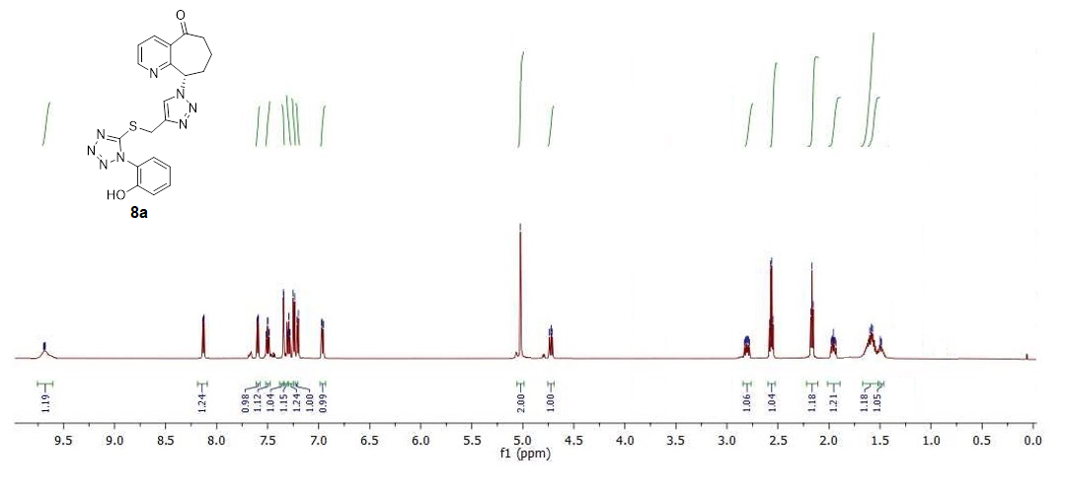
Figure S1: ¹H NMR spectra of 8a

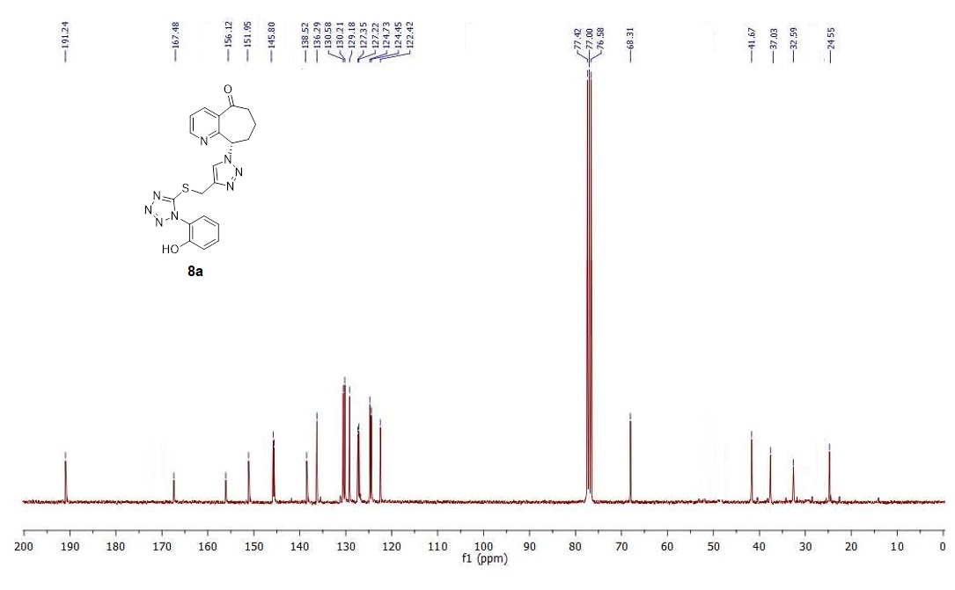
Figure S2: ¹³C NMR spectra of 8a

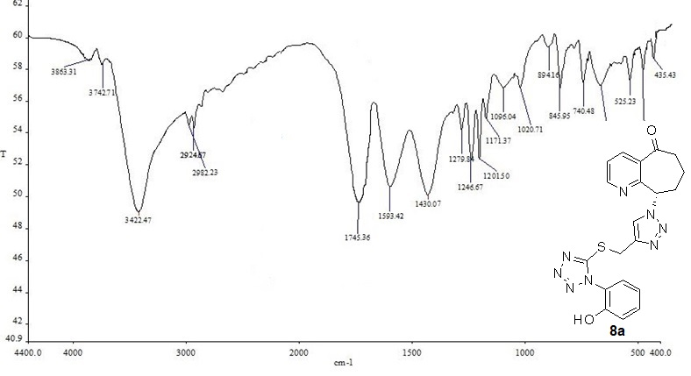
Figure S3: IR spectra of 8a
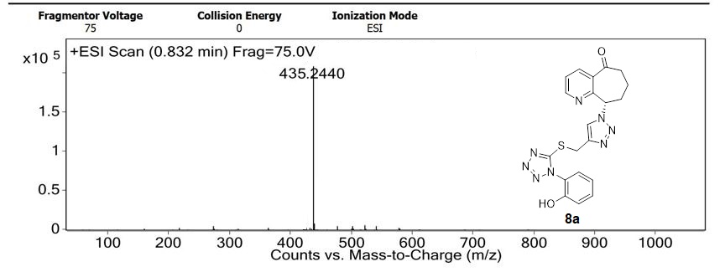
Figure S4: Mass spectra of 8a

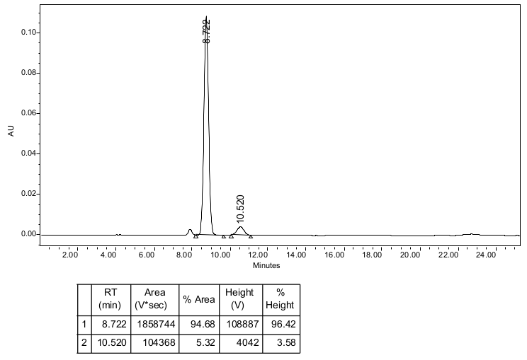
(S)-8a
Figure S5: HPLC chromatogram of (S)-8a.

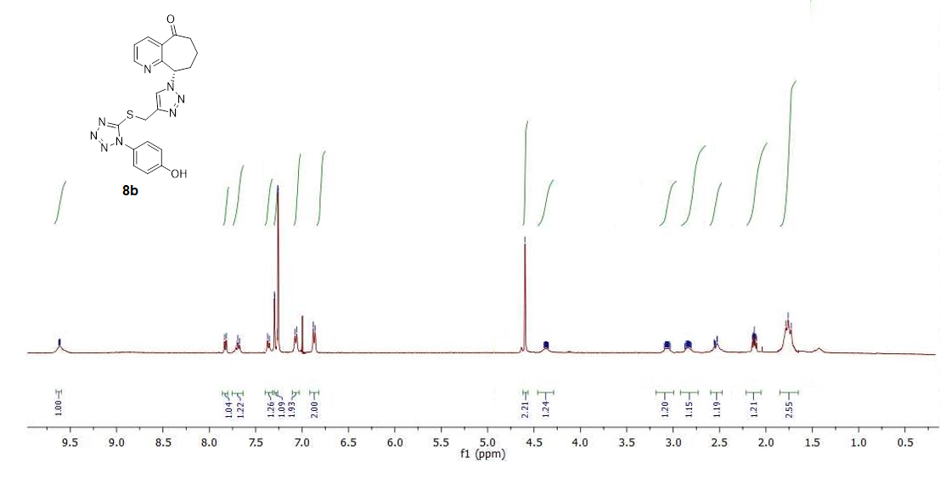
Figure S6: ¹H NMR spectra of 8b
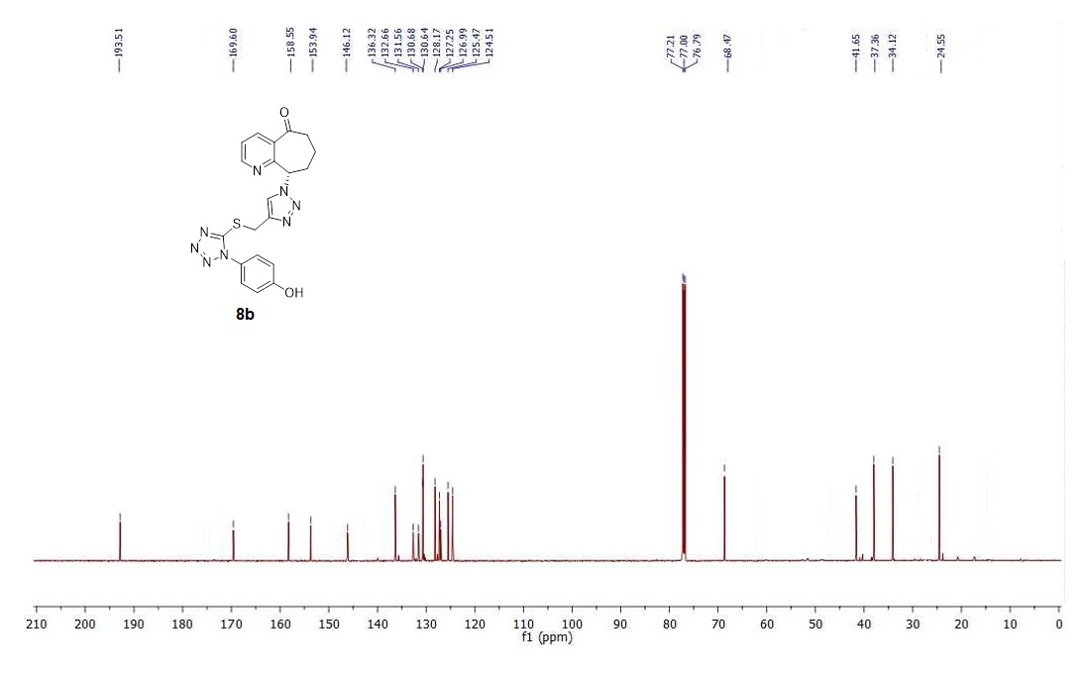
Figure S7: ¹³C NMR spectra of 8b

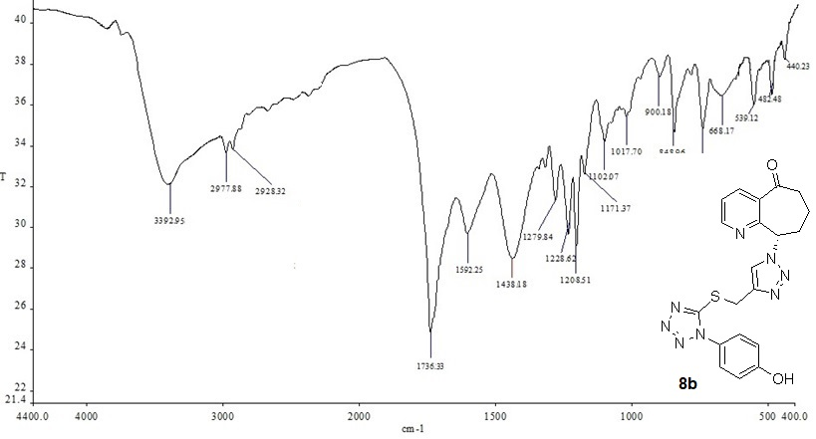
Figure S8: IR spectra of 8b

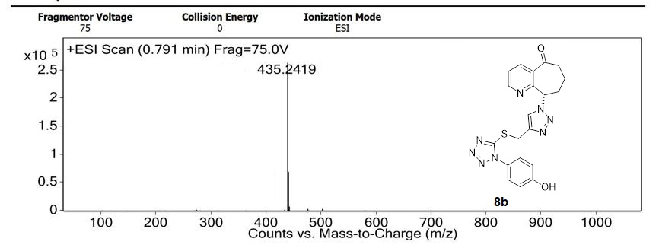
Figure S9: Mass spectra of 8b

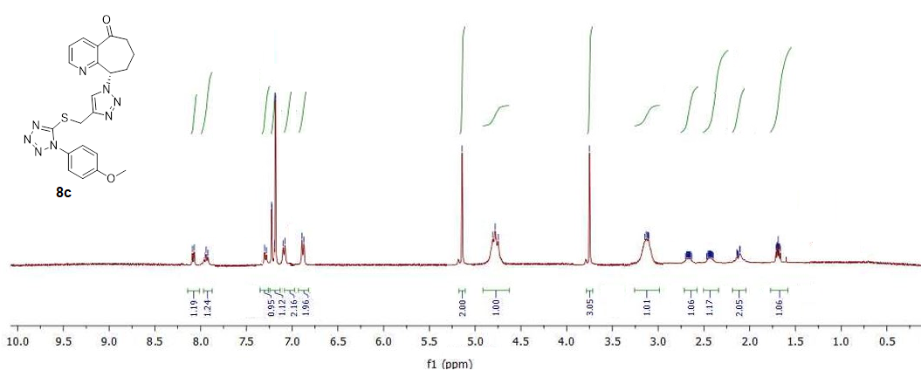
Figure S10: ¹H NMR spectra of 8c
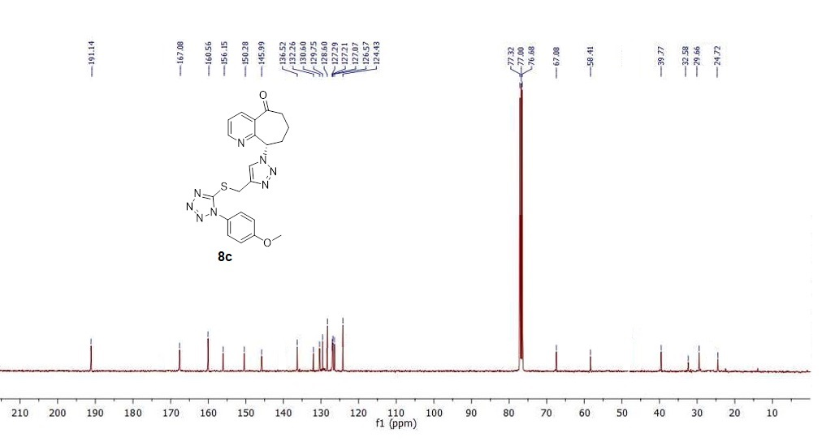
Figure S11: ¹³C NMR spectra of 8c

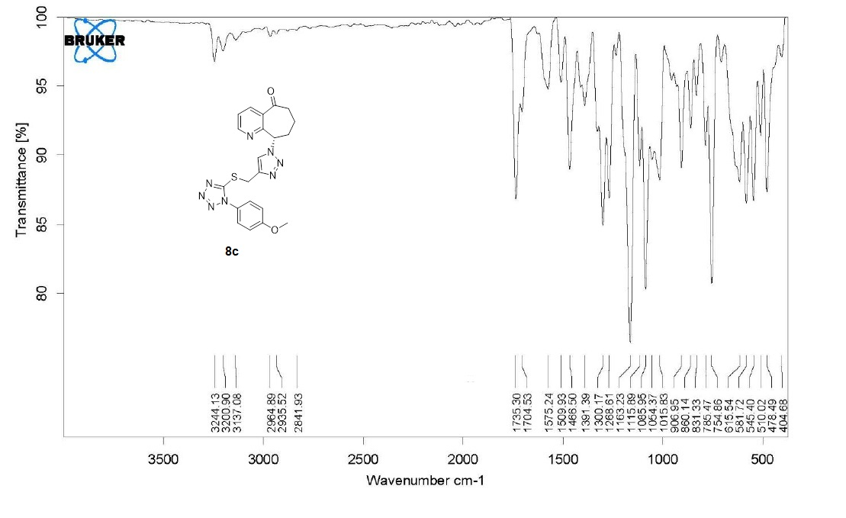
Figure S12: IR spectra of 8c

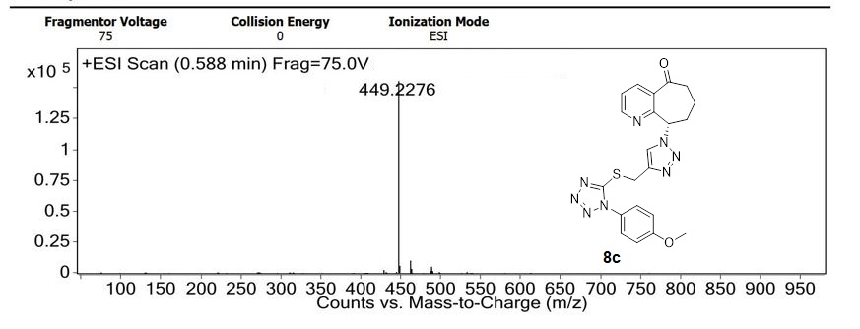
Figure S13: Mass spectra of 8c

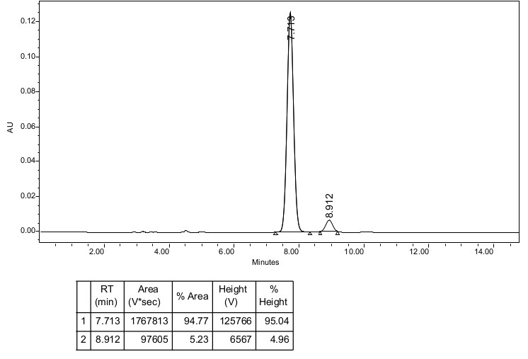
(S)-8c
Figure S14: HPLC chromatogram of (S)-8c.

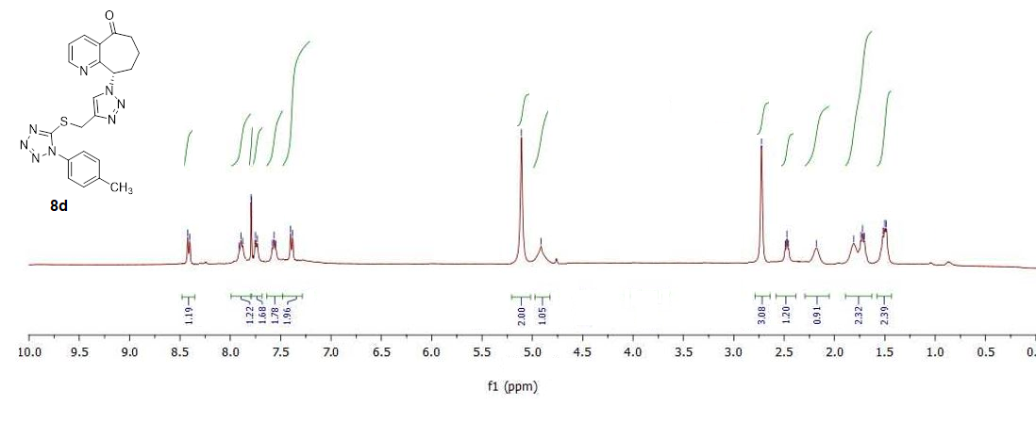
Figure S15: ¹H NMR spectra of 8d
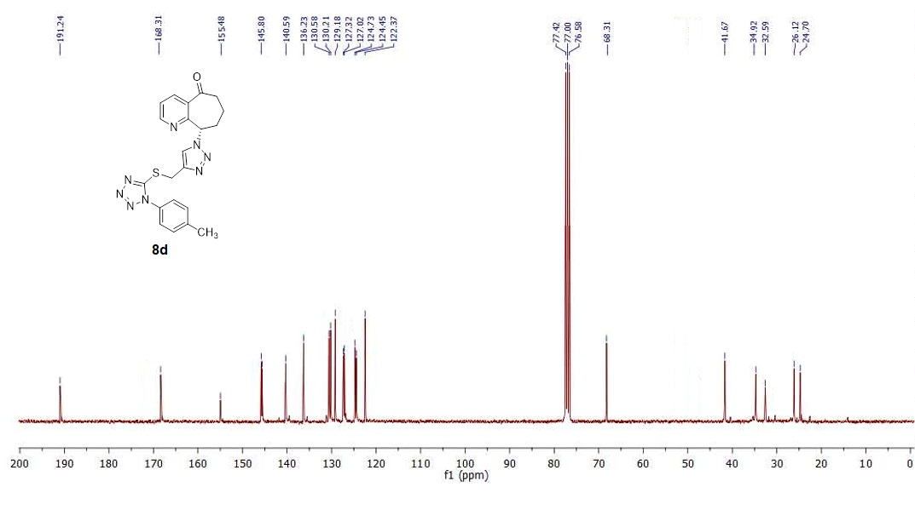
Figure S16: ¹³C NMR spectra of 8d
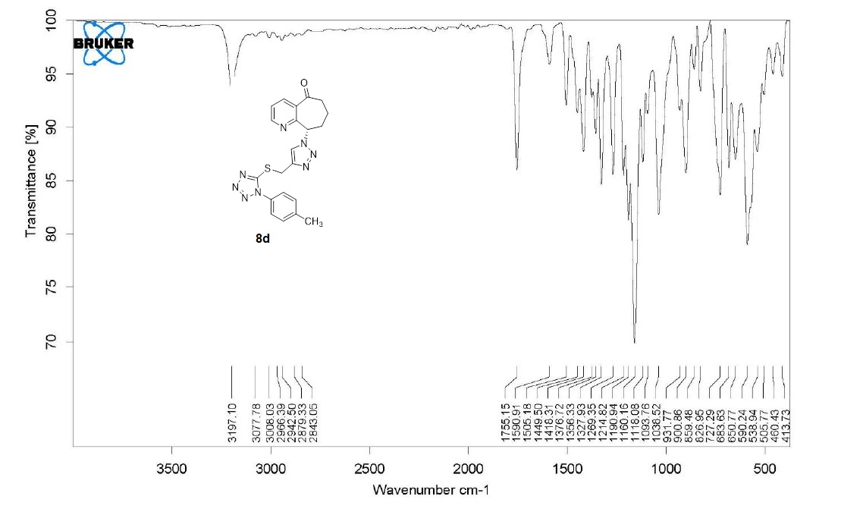
Figure S17: IR spectra of 8d

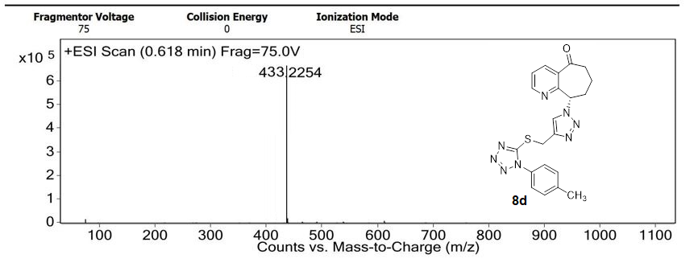
Figure S18: Mass spectra of 8d

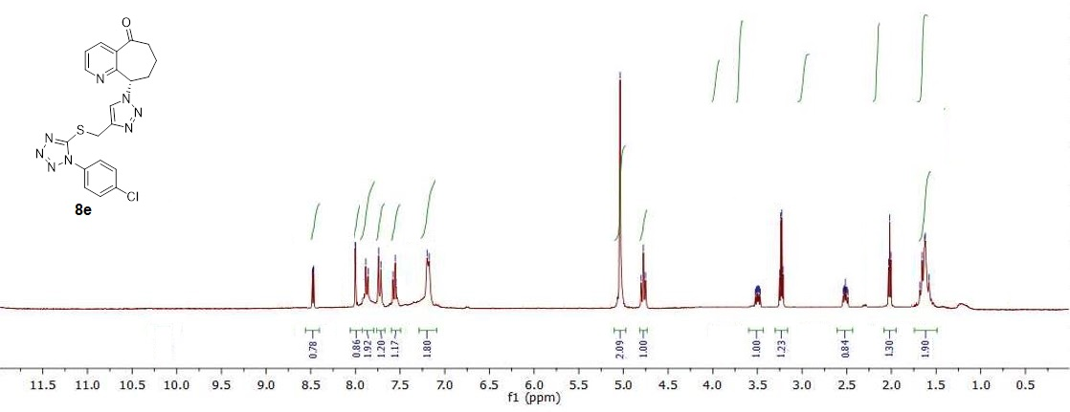

Figure S19: ¹H NMR spectra of 8e

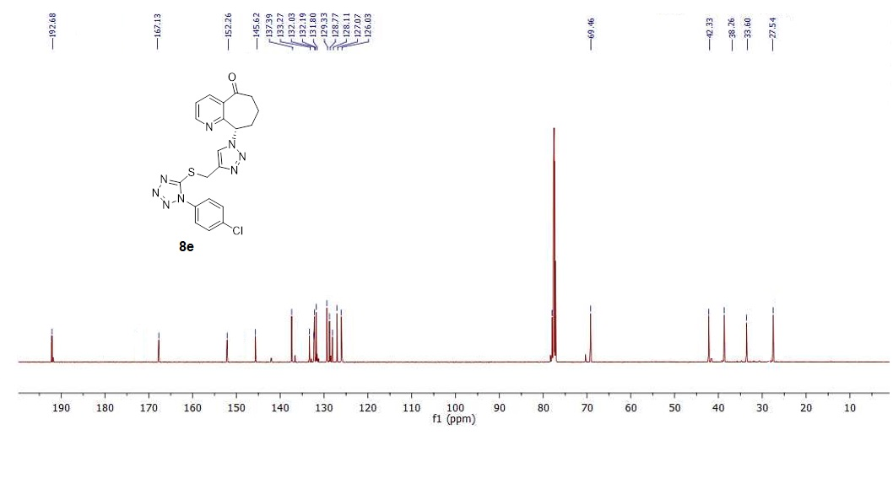
Figure S20: ¹³C NMR spectra of 8e
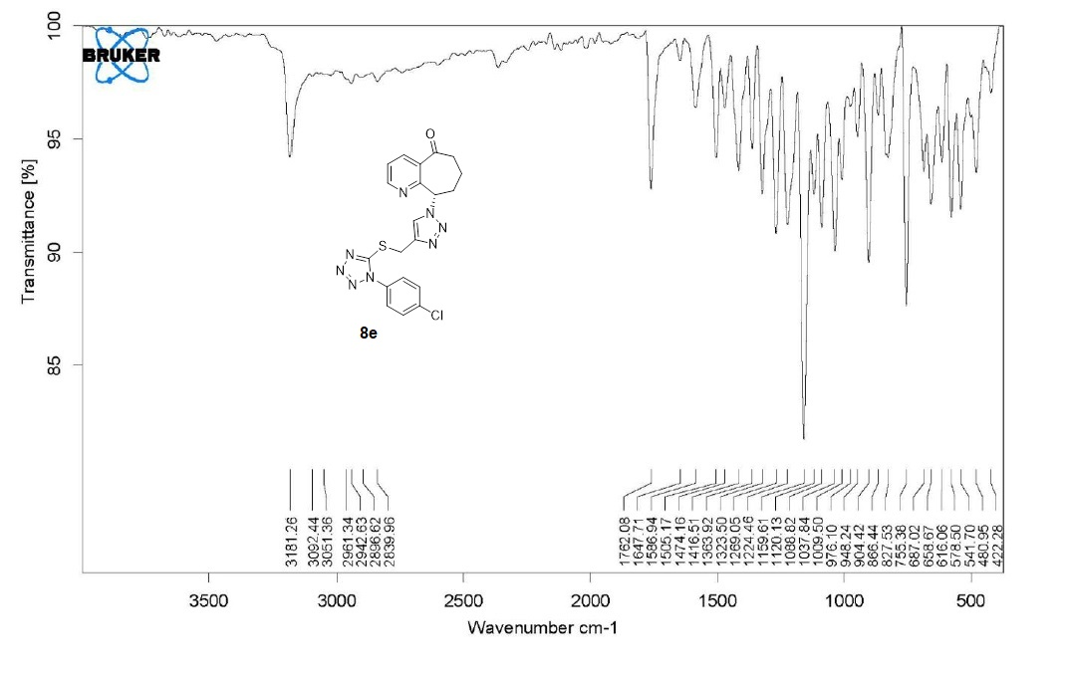
Figure S21: IR spectra of 8e

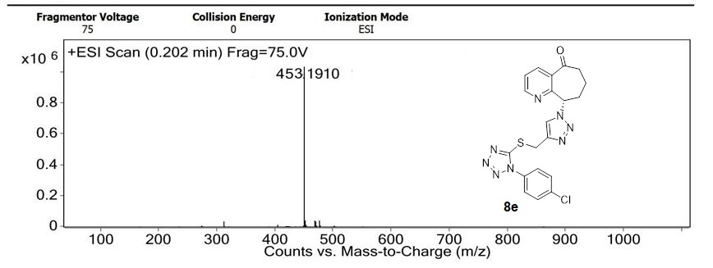
Figure S22: Mass spectra of 8e

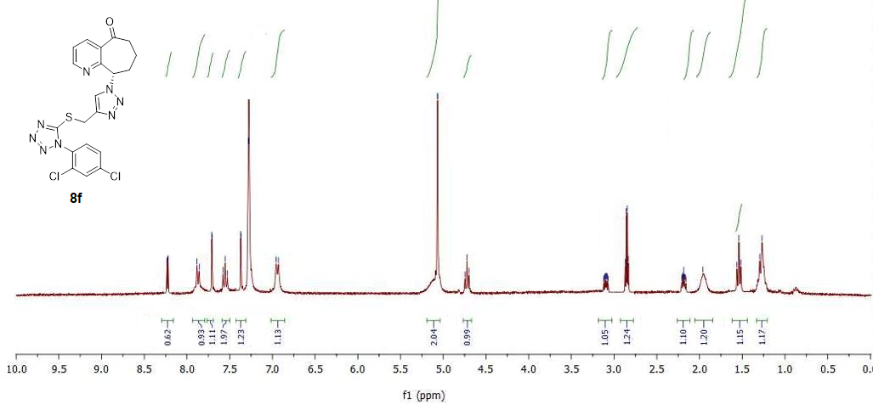
Figure S23: ¹H NMR spectra of 8f

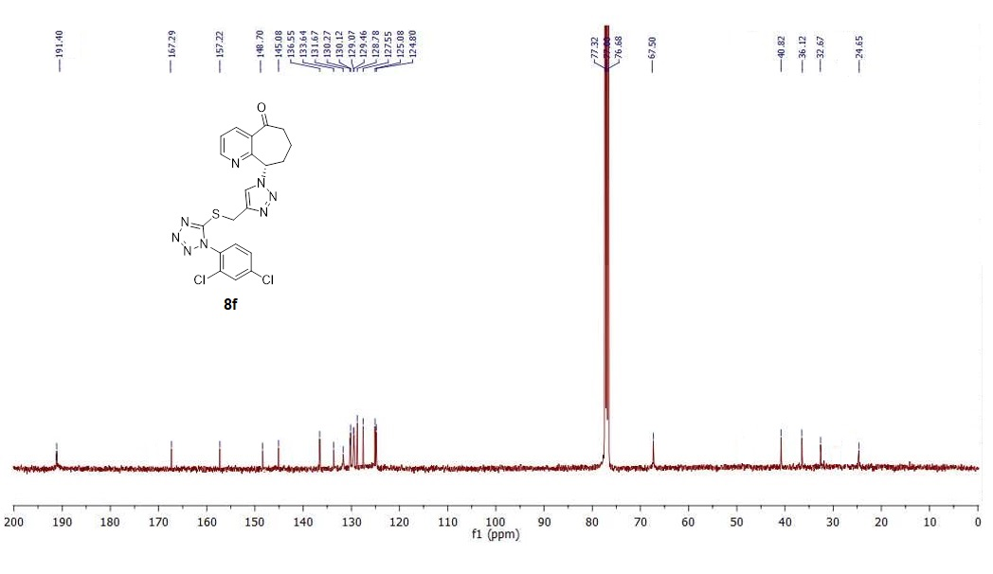
Figure S24: ¹³C NMR spectra of 8f

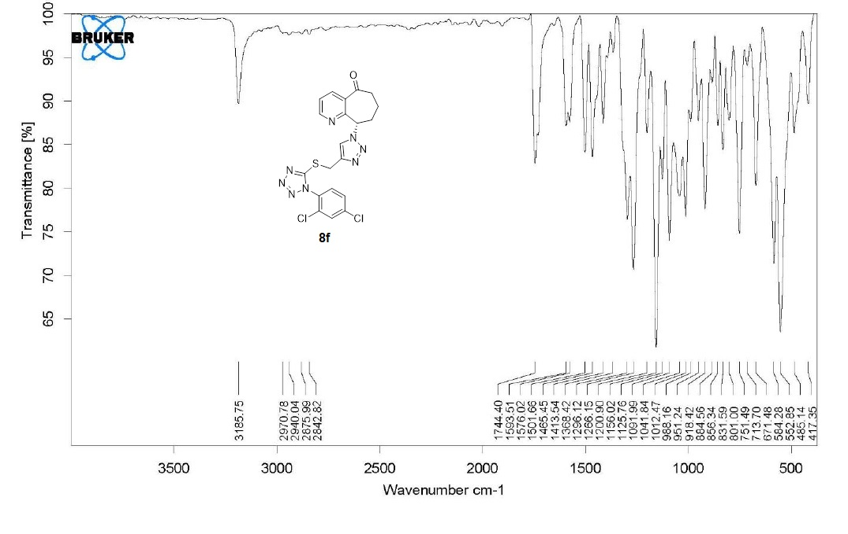
Figure S25: IR spectra of 8f

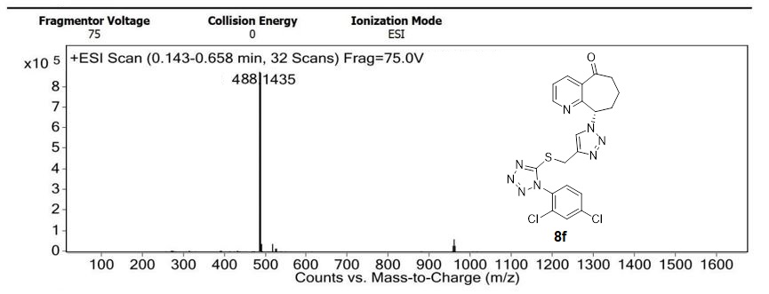
Figure S26: Mass spectra of 8f

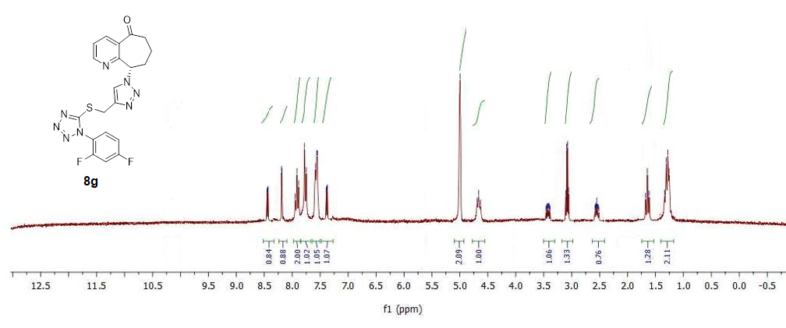
Figure S27: ¹H NMR spectra of 8g

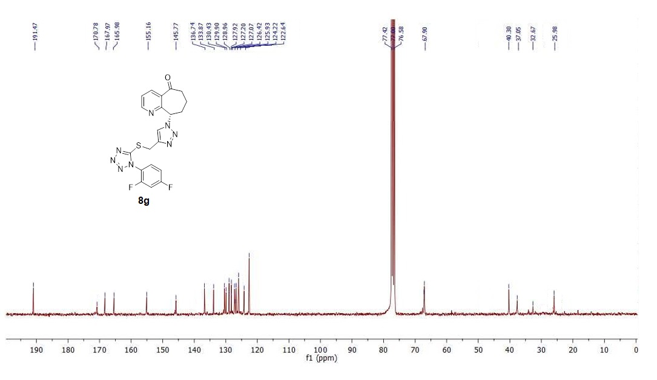
Figure S28: ¹³C NMR spectra of 8g
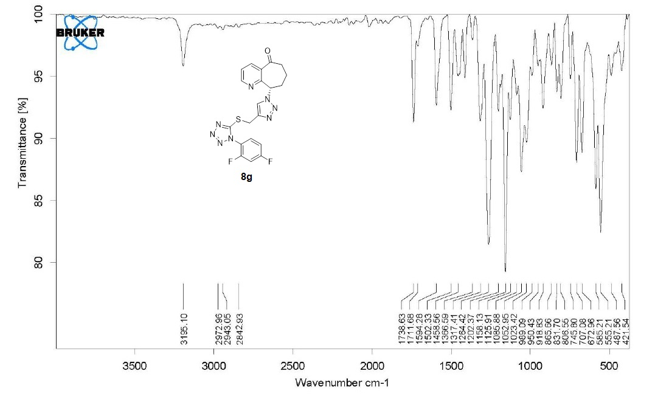
Figure S29: IR spectra of 8g

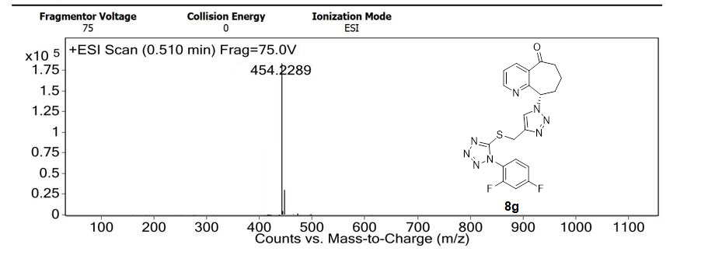
Figure S30: Mass spectra of 8g

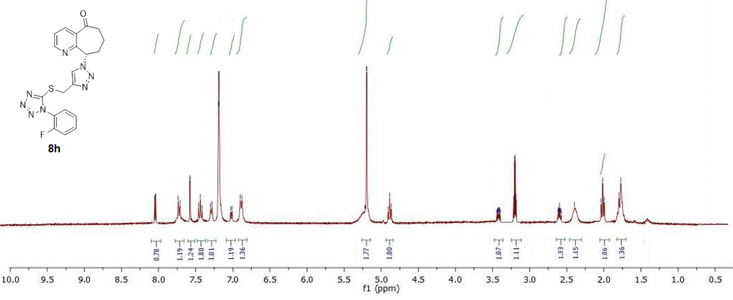
Figure S31: ¹H NMR spectra of 8h
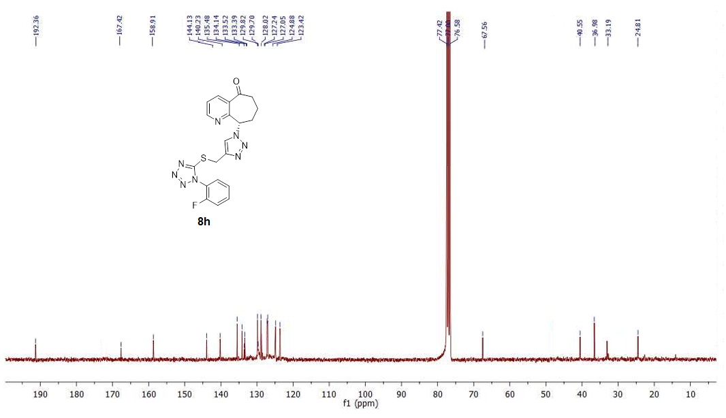
Figure S32: ¹³C NMR spectra of 8h

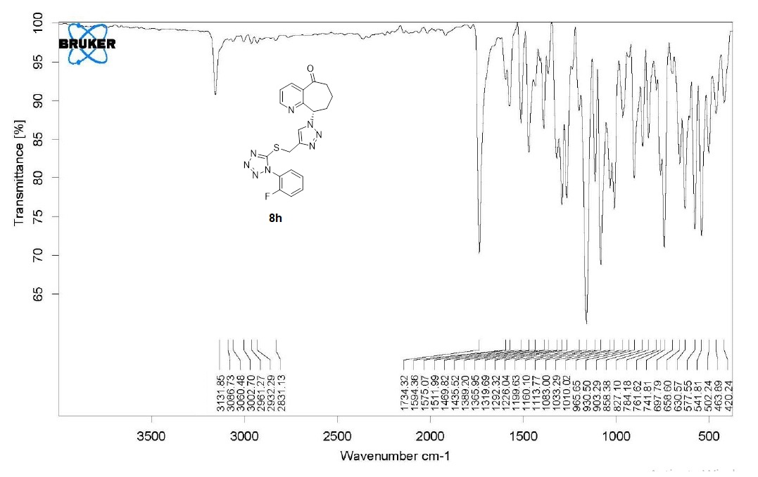
Figure S33: IR spectra of 8h

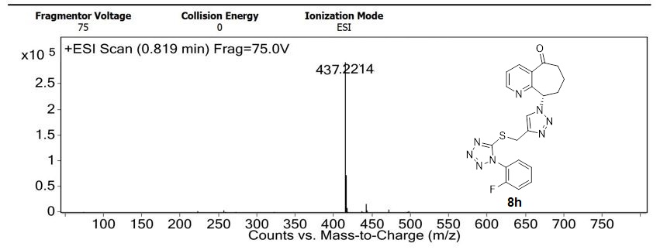
Figure S34: Mass spectra of 8h

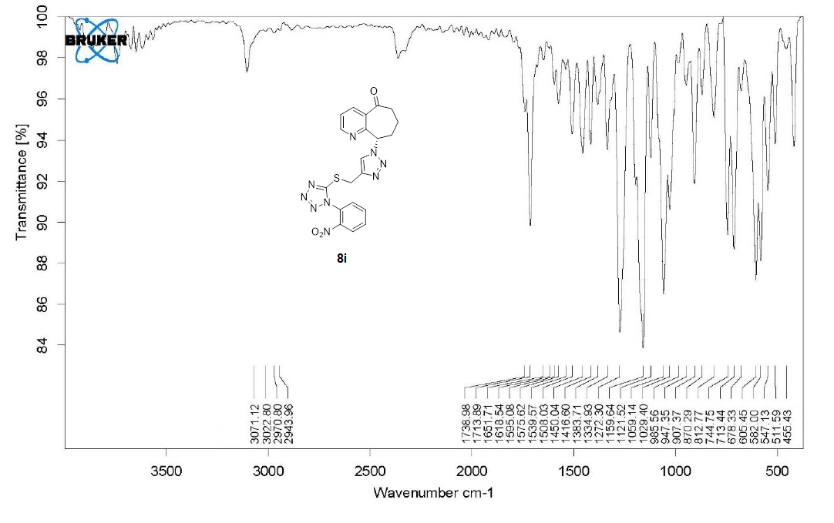
Figure S35: IR spectra of 8i

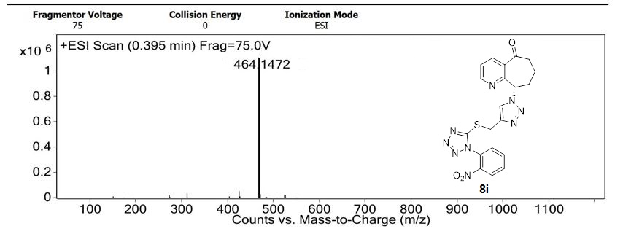
Figure S36: Mass spectra of 8i

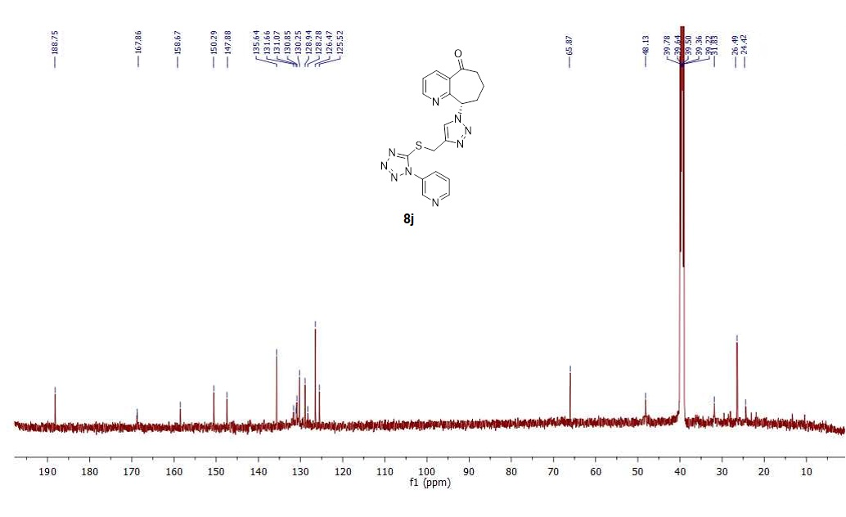
Figure S37: ¹³C NMR spectra of 8j
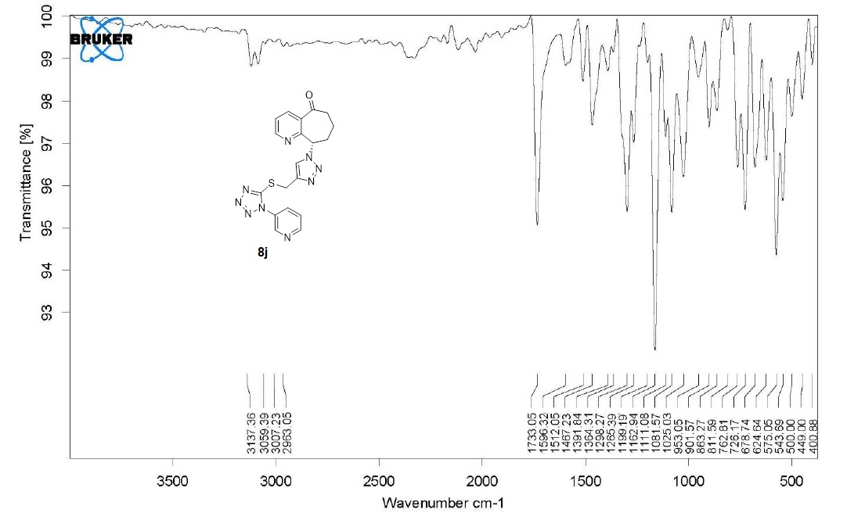
Figure S38: IR spectra of 8j

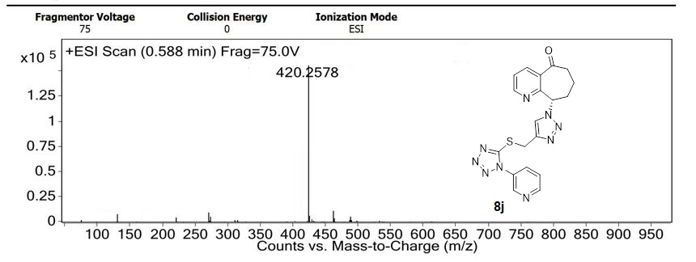
Figure S39: Mass spectra of 8j
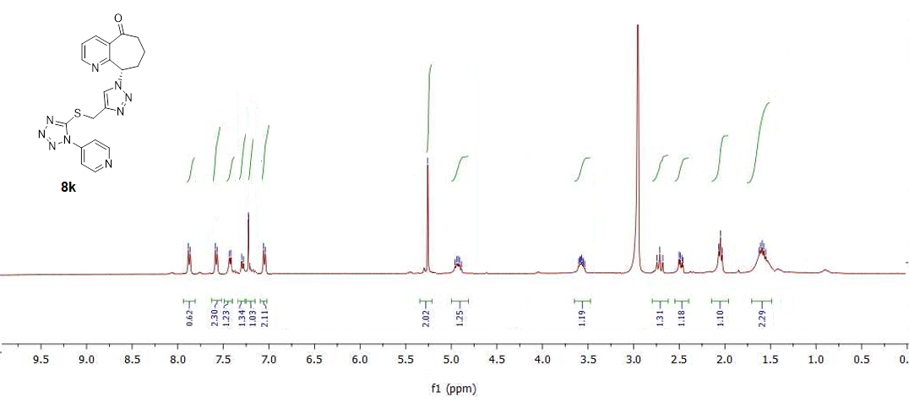
Figure S40: ¹H NMR spectra of 8k

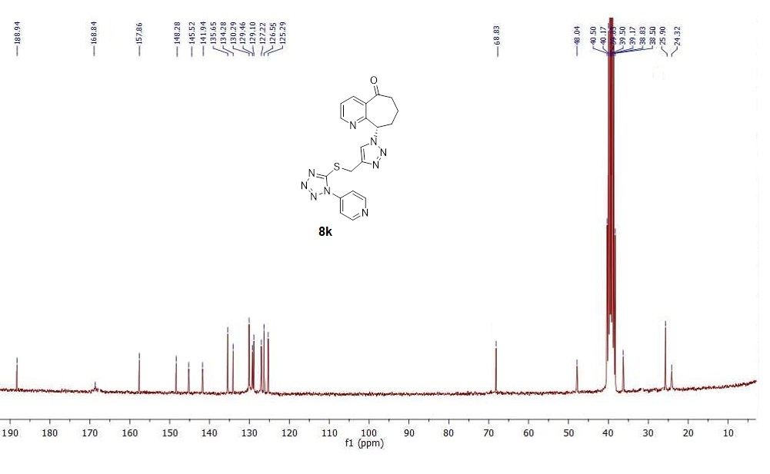
Figure S41: ¹³C NMR spectra of 8k

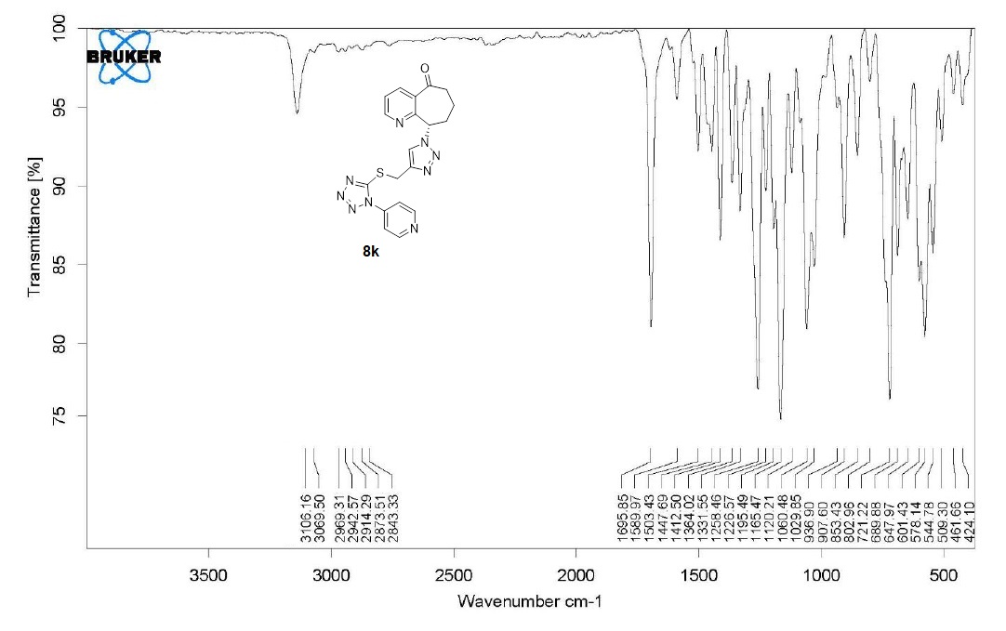
Figure S42: IR spectra of 8k

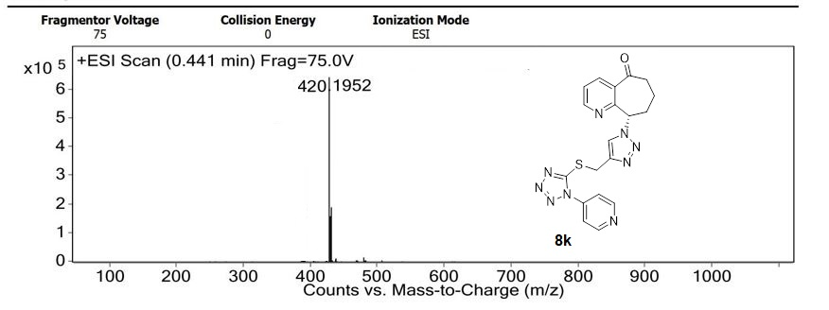
Figure S43: Mass spectra of 8k

