Appendix
Exhibit-1: Demographic profile of respondents.
Particular | Category | Frequency | Percentage
Religion
 | Hindu | 187 | 92.57
 | Muslim | 9 | 4.46
 | Christian | 4 | 1.98
 | Others | 2 | 0.99
Gender
 | Male | 117 | 57.92
 | Female | 85 | 42.08
Annual Income in Rs.
 | <=1Lac | 30 | 14.85
 | 1Lac-5Lac | 40 | 19.8
 | 5Lac-10Lac | 80 | 39.6
 | 10Lac Above | 52 | 25.74
No. of brothers and Sisters in Family
 | 1 | 11 | 5.45
 | 2 | 106 | 52.48
 | 3 | 65 | 32.18
 | 4 | 20 | 9.9

Exhibit-2
Model Summary
Model | R | R Square | Adjusted R Square | Std. Error of the Estimate
1 | .898ª | .807 | .791 | .630
a. Predictors: (Constant), Statements for Factor Analysis S1, S2, S3, S4, S5, S6, S7, S8, S9, S10, S11, S12, S13, S14, S15, S16

Exhibit-3
ANOVAª
Model |  | Sum of Squares | df | Mean Square | F | Sig.
1 | Regression | 307.158 | 16 | 19.197 | 48.427 | .000^{b}
 | Residual | 73.337 | 186 | .396
 | Total | 380.495 | 202
a. Dependent Variable: Product Category(FMCG, FMCD, CD, Bike and Car)
b. Predictors: (Constant), Statements for Factor Analysis S1, S2, S3, S4, S5, S6, S7, S8, S9, S10, S11, S12, S13, S14, S15, S16

Exhibit-4
Model | Unstandardized Coefficients |  | Standardized Coefficients | t | Sig.
 | B | Std. Error | Beta
(Constant) | .692 | .522 |  | 1.326 | .186
S1 | .255 | .039 | .262 | 6.532 | .000
S2 | .310 | .084 | .252 | 3.676 | .000
S3 | .235 | .127 | .189 | 1.850 | .066
S4 | -.672 | .107 | -.689 | -6.285 | .000
S5 | .514 | .098 | .187 | 5.237 | .000
S6 | -.176 | .138 | -.097 | -1.274 | .204
S7 | .368 | .111 | .230 | 3.323 | .001
S8 | .087 | .078 | .075 | 1.120 | .264
S9 | .515 | .088 | .429 | 5.868 | .000
S10 | .317 | .099 | .337 | 3.188 | .002
S11 | -.172 | .150 | -.124 | -1.146 | .253
S12 | .229 | .101 | .167 | 2.268 | .024
S13 | -.316 | .105 | -.324 | -2.994 | .003
S14 | -.168 | .119 | -.085 | -1.415 | .159
S15 | -.477 | .098 | -.478 | -4.884 | .000
S16 | -.218 | .089 | -.167 | -2.451 | .015
a. Dependent Variable: Product Category(FMCG, FMCD, CD, Bike and Car)

Exhibit-5: Perceptual map about colour, shape, design and size.
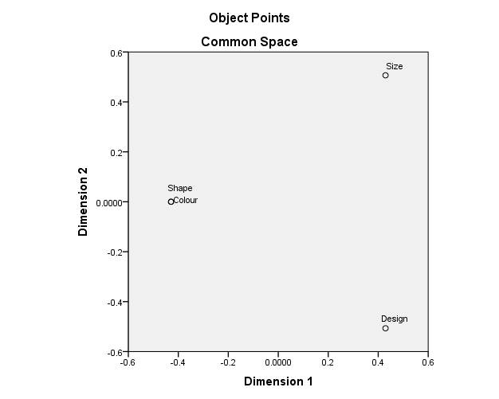

Exhibit-6: Perceptual map of different colours.
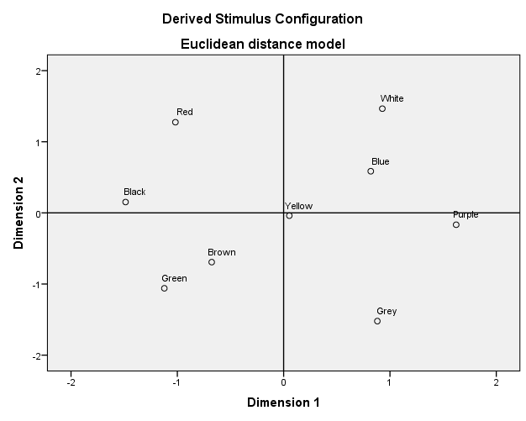
Exhibit-7: Perceptual map of different brands of car on the basis of brand colour.
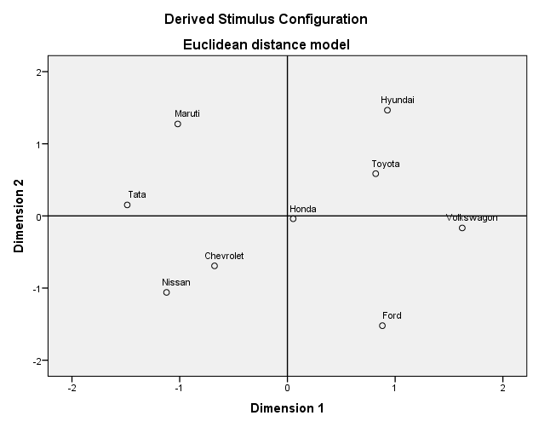
Exhibit-8
Reliability Statistics
Cronbach's Alpha | N of Items
.929 | 16

Exhibit-9
KMO and Bartlett's Test
Kaiser-Meyer-Olkin Measure of Sampling Adequacy. |  | .878
Bartlett's Test of Sphericity | Approx. Chi-Square | 3.826E3
 | df | 120
 | Sig. | .000

Exhibit-10: (Eigen values and Cumulative eigen values of factors).
Component | Statements | Initial Eigenvalues
 |  | Total | % of Variance | Cumulative %
S1 | I always prefer multi body colour. | 9.515 | 59.469 | 59.469
S2 | My liking is mostly based on the unique indicator position and colour. | 1.599 | 9.994 | 69.463
S3 | I give more attention to the unique colour of dashboard. | 1.164 | 7.273 | 76.736
S4 | The vehicle looks good if the interior meter display colour is good. | 1.071 | 6.694 | 83.430
S5 | I like the steel colour of door handle. | .720 | 4.502 | 87.931
S6 | It looks better if the front bumper is steel grill. | .464 | 2.898 | 90.829
S7 | It looks nice if the colour of wheel is metallic alloy. | .380 | 2.374 | 93.203
S8 | Unique number plate light and colour will give some satisfaction. | .244 | 1.523 | 94.726
S9 | Contrast body colour has greater impact on customer. | .193 | 1.208 | 95.935
S10 | Innovative interior colour will give a good impression. | .177 | 1.107 | 97.042
S11 | Contrast interior colour has better look than others. | .130 | .813 | 97.855
S12 | Different backlight colour will give more attention to customers. | .105 | .654 | 98.509
S13 | My attention is more towards unique mirror colours. | .083 | .517 | 99.026
S14 | Unique Head light colour is giving more satisfaction on look. | .065 | .407 | 99.433
S15 | Unique body colour which is not available with other brands gives more attention. | .052 | .325 | 99.757
S16 | Body colour bumper changes the entire look of the product. | .039 | .243 | 100.000

Exhibit-11: (Factors with respective variables for attitude development).
(F1)  Cues | I like the steel colour of door handle. (s5)
 | It looks better if the front bumper is steel grill. (s6)
 | It looks nice if the colour of wheel is metallic alloy. (s7)
 | My attention is more towards unique mirror colours. (s13)
(F2)  Aesthetic | I give more attention to the unique colour of dashboard. (s3)
 | The vehicle looks good if the interior meter display colour is good. (s4)
 | Innovative interior colour will give a good impression.(s10)
 | Contrast interior colour has better look than others.(s11)
(F3)  Uniqueness | My liking is mostly based on the unique indicator position and colour. (s2)
 | Unique number plate light and colour will give some satisfaction. (s8)
 | Different backlight colour will give more attention to customers. (s12)
(F4)  Physical Appearance | I always prefer multi body colour. (s1)
 | Contrast body colour has greater impact on customer. (s9)
 | Unique Head light colour is giving more satisfaction on look. (s14)
 | Unique body colour which is not available with other brands gives more attention. (s15)
 | Body colour bumper changes the entire look of the product. (s16)

Exhibit-12: Ranking of Factors on Satisfaction Level.
Factors | Factor Loadings | Rank
F4(Physical Appearance) | 3.66 | 1
F2(Aesthetic) | 3.16 | 2
F1(Cues) | 2.88 | 3
F3(Uniqueness) | 2.20 | 4

