**Complementary Data**

Scree plot of each channel (Red, Blue and green) for PCA analysis

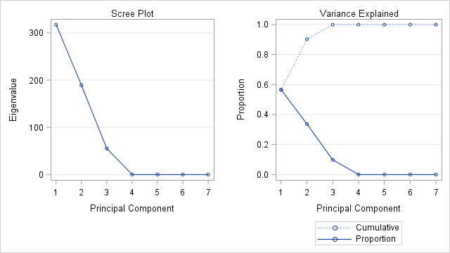

Red channel

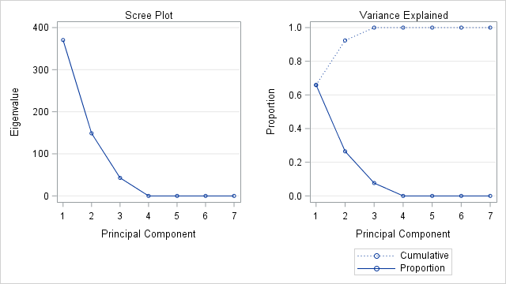

Blue channel

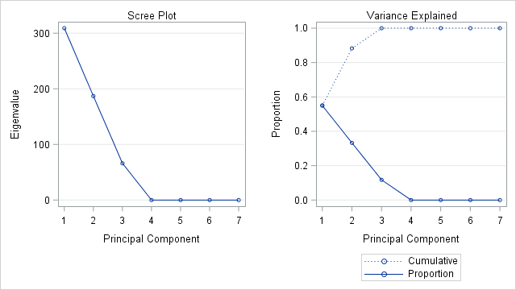

Green channel