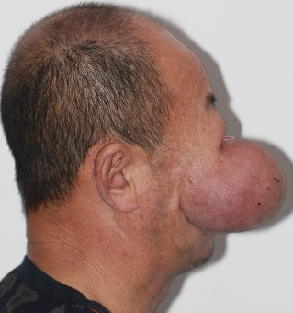
Supplemental Figure 1: A huge subcutaneous tissue mass lesion in right infraorbital region of face.
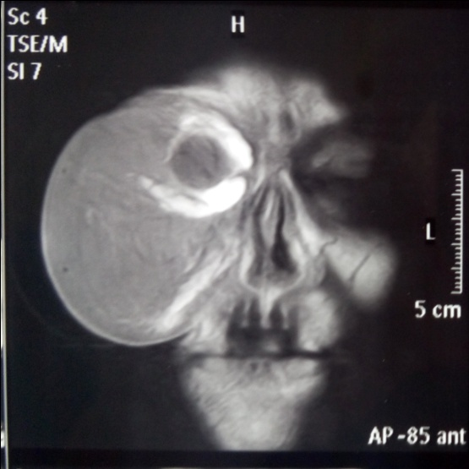
Supplemental Figure 2: Magnetic resonance imaging (MRI) of the mass lesion.
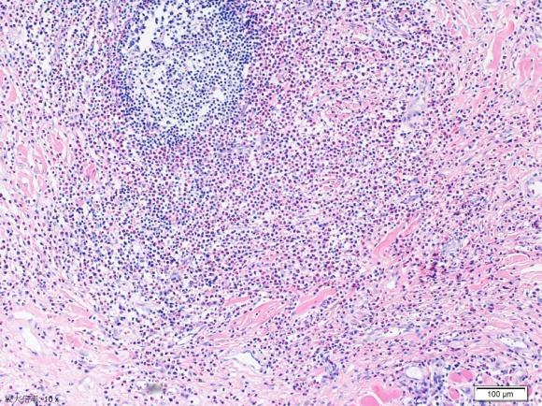
Supplemental Figure 3: Histopathological examination of the mass.

